1. Adicionar dependencias (spring-security-web e spring-security-config)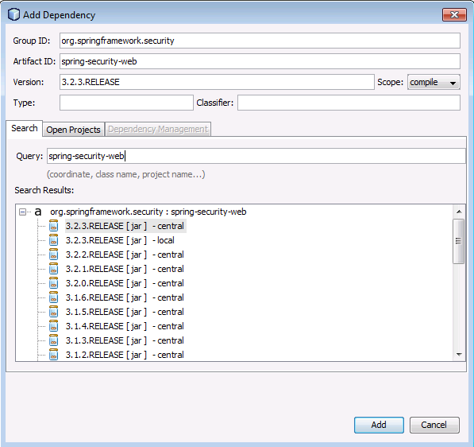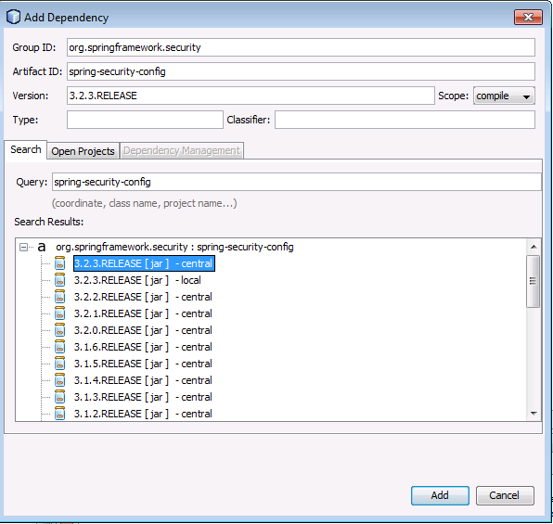
2. Adicionar class SecurityConfig:

import org.springframework.beans.factory.annotation.Autowired; import org.springframework.context.annotation.\*;

import org.springframework.security.config.annotation.authentication.builders.\*;

import org.springframework.security.config.annotation.web.configuration.\*; @Configuration @EnableWebSecurity public class SecurityConfig extends WebSecurityConfigurerAdapter { @Autowired public void configureGlobal(AuthenticationManagerBuilder auth) throws Exception { auth .inMemoryAuthentication() .withUser("user").password("password").roles("USER"); } }